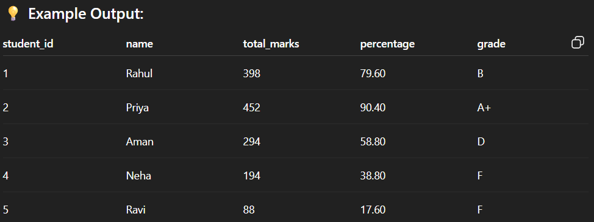

MySQL-based Marksheet system

✅ Features:
- Total subject marks calculate hote hain
- Percentage nikala jaata hai
- Grade assign hota hai condition ke basis pe

Step 1: Database Create Karna
CREATE DATABASE student_marksheet;

Step 2: Table Create Karna
USE student_marksheet;

CREATE TABLE marksheet (
student_id INT PRIMARY KEY AUTO_INCREMENT,
name VARCHAR(100),
subject1 INT,
subject2 INT,
subject3 INT,
subject4 INT,
subject5 INT
);

Step 3: Sample Data Insert Karna
INSERT INTO marksheet (name, subject1, subject2, subject3, subject4, subject5) VALUES
('Rahul', 80, 75, 68, 90, 85),
('Priya', 95, 88, 92, 86, 91),
('Aman', 55, 60, 58, 62, 59),
('Neha', 35, 40, 38, 42, 39),
('Ravi', 20, 18, 25, 15, 10);

Step 4: Simple Total Marks, Percentage aur Grade
SELECT
student_id,
name,
subject1 + subject2 + subject3 + subject4 + subject5 AS total_marks,
ROUND((subject1 + subject2 + subject3 + subject4 + subject5)/5, 2) AS percentage,

CASE
WHEN (subject1 + subject2 + subject3 + subject4 + subject5)/5 >= 90 THEN 'A+'
WHEN (subject1 + subject2 + subject3 + subject4 + subject5)/5 >= 80 THEN 'A'
WHEN (subject1 + subject2 + subject3 + subject4 + subject5)/5 >= 70 THEN 'B'
WHEN (subject1 + subject2 + subject3 + subject4 + subject5)/5 >= 60 THEN 'C'
WHEN (subject1 + subject2 + subject3 + subject4 + subject5)/5 >= 50 THEN 'D'
ELSE 'F'
END AS grade

FROM marksheet;

💡 Example Output:
student_id | name | total_marks | percentage | grade
1 | Rahul | 398 | 79.60 | B
2 | Priya | 452 | 90.40 | A+
3 | Aman | 294 | 58.80 | D
4 | Neha | 194 | 38.80 | F
5 | Ravi | 88 | 17.60 | F

: ROUND((subject1 + subject2 + subject3 + subject4 + subject5)/5, 2) AS percentage,

• subject1 + subject2 + ... + subject5
→ Student ke 5 subjects ke marks ka t+otal nikaal raha hai.
• /5
→ Total ko 5 se divide kar raha hai, jisse average marks yaani percentage milta hai (kyunki total 5 subjects hain).
• ROUND(..., 2)
→ Percentage ko 2 decimal places tak round kar raha hai.
Jaise agar result 78.666666 ho toh 78.67 ban jaayega.
• AS percentage
→ Is result ka naam percentage diya ja raha hai (yeh SQL ka alias hota hai).
TASK 2
ID | Name | Hindi | English | Math | Science | SST | Total | % | Grade
1 | Rahul | 80 | 75 | 68 | 90 | 85 | 398 | 79.60 | B
2 | Priya | 95 | 88 | 92 | 86 | 91 | 452 | 90.40 | A+

Sol

🎯 Objective:
SQL query se hi:
- Subject-wise marks dikhana
- Total marks nikalna
- Percentage nikalna
- Grade assign karna

✅ Step 1: Database Create
CREATE DATABASE student_marksheet;
USE student_marksheet;

✅ Step 2: Table Create
CREATE TABLE marksheet (
student_id INT PRIMARY KEY AUTO_INCREMENT,
name VARCHAR(100),
subject1 INT, -- Hindi
subject2 INT, -- English
subject3 INT, -- Math
subject4 INT, -- Science
subject5 INT -- SST
);

✅ Step 3: Data Insert
INSERT INTO marksheet (name, subject1, subject2, subject3, subject4, subject5) VALUES
('Rahul', 80, 75, 68, 90, 85),
('Priya', 95, 88, 92, 86, 91),
('Aman', 55, 60, 58, 62, 59),
('Neha', 35, 40, 38, 42, 39),
('Ravi', 20, 18, 25, 15, 10);

✅ Step 4: Final SQL Query — Marksheet Display
SELECT
student_id,
name,
subject1 AS Hindi,
subject2 AS English,
subject3 AS Math,
subject4 AS Science,
subject5 AS SST,

(subject1 + subject2 + subject3 + subject4 + subject5) AS total_marks,

ROUND((subject1 + subject2 + subject3 + subject4 + subject5) / 5, 2) AS percentage,

CASE
WHEN (subject1 + subject2 + subject3 + subject4 + subject5) / 5 >= 90 THEN 'A+'
WHEN (subject1 + subject2 + subject3 + subject4 + subject5) / 5 >= 80 THEN 'A'
WHEN (subject1 + subject2 + subject3 + subject4 + subject5) / 5 >= 70 THEN 'B'
WHEN (subject1 + subject2 + subject3 + subject4 + subject5) / 5 >= 60 THEN 'C'
WHEN (subject1 + subject2 + subject3 + subject4 + subject5) / 5 >= 50 THEN 'D'
ELSE 'F'
END AS grade
FROM marksheet;

📋 Output Format:
ID | Name | Hindi | English | Math | Science | SST | Total | % | Grade
1 | Rahul | 80 | 75 | 68 | 90 | 85 | 398 | 79.60 | B
2 | Priya | 95 | 88 | 92 | 86 | 91 | 452 | 90.40 | A+

TASK 3

🎓 SQL Assignment: Marksheet Data Analysis

📋 Instructions for Students:
You are given the marksheet table of 10 students. Each student has marks in 5 subjects:
- Hindi
- English
- Math
- Science
- SST
The table structure is as follows:
student_id | name | subject1 | subject2 | subject3 | subject4 | subject5
(Auto ID) | Name | Hindi | English | Math | Science | SST
Q :
DATA :
('Rahul', 80, 75, 68, 90, 85),
('Priya', 95, 88, 92, 86, 91),
('Aman', 55, 60, 58, 62, 59),
('Neha', 35, 40, 38, 42, 39),
('Ravi', 20, 18, 25, 15, 10),
('Simran', 88, 84, 90, 87, 89),
('Karan', 65, 70, 68, 60, 72),
('Anjali', 78, 80, 82, 79, 85),
('Vikas', 45, 50, 48, 52, 49),
('Divya', 91, 89, 93, 88, 90)

Question :>
• Display each student’s total marks.
• Calculate and display the percentage of each student.
• Assign grades based on percentage using CASE statement.
• Find the topper of the class.
• Find how many students failed (i.e., percentage less than 50%).
• Display subject-wise marks, total, percentage, and grade together.
• Count how many students got ‘A’ grade or above.
• Sort the marksheet in descending order of total marks.

